KHARKIV NATIONAL MEDICAL UNIVERSITY

DEPARTMENT OF MEDICAL GENETICS

TOPIC:PHNEYLKETONURIA

PROFESSOR: YULIYA BORISIVNA
NAME: JOSHNA THAPPA
GROUP AND COURSE: GROUP NO:1ST AND 5TH

Overview
- Autosomal recessive metabolic genetic disorder
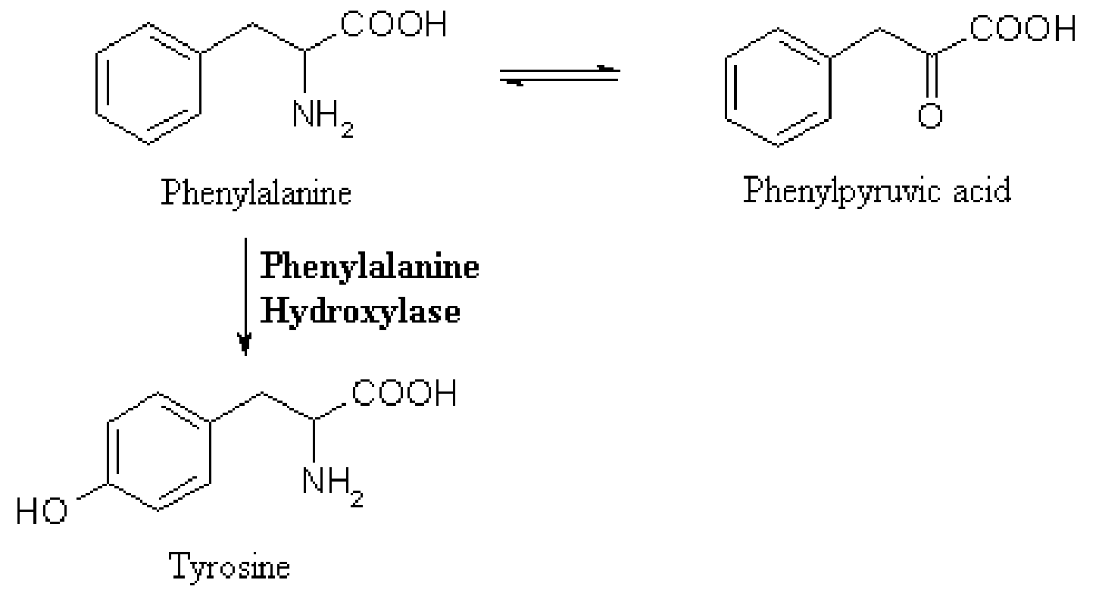
- Mutation in the gene for phenylalanine hydroxylase(PAH).
- When PAH activity is reduced, phenylalanine accumulates and is converted into phenylpyruvate(phenylketone), which can be detected in the urine.
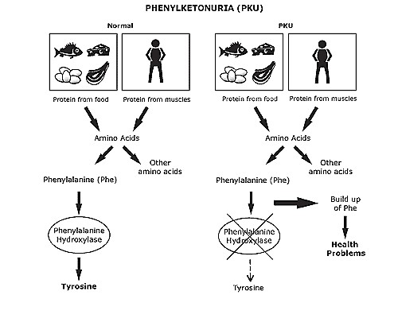

Overview
- Untreated PKU can lead to intellectual disability, seizures, and other serious medical problems.
- Patients who are diagnosed early and maintain a strict diet can have a normal life span with normal mental development.
- PKU is rare – it is estimated to affect 1 in every 10,000 babies. 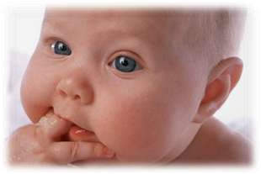

Etiology
- Autosomal recessive disorder caused by mutation in PAH gene
- Located on 12th chromosome.
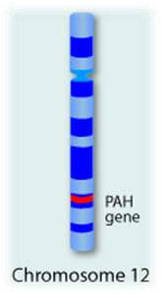
- A carrier does not have symptoms of the disease, but can pass on the defective gene to his or her children.
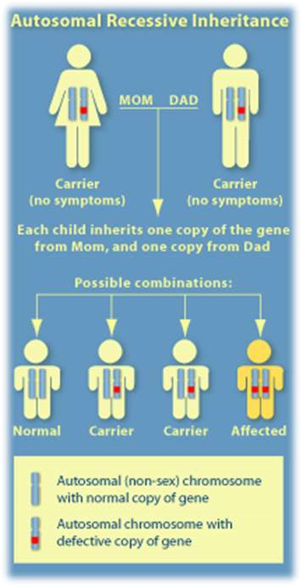

Symptoms
- Most babies with phenylketonuria appear healthy at birth.

- Symptoms usually only develop due to complications that arise if the condition is not treated properly.
- If it isn't treated, damage to the brain and nervous system can lead to:
  - learning disabilities
  - behavioural difficulties
  - epilepsy

Symptoms
- Often have lighter skin, hair, and eyes than brothers or sisters without the disease.

- Other symptoms include:
✓Eczema
✓Recurrent vomiting
✓Jerking movements in arms and legs
✓Tremors
✓Mood disorders
✓Microcephaly,

Diagnosis
- Screening on blood samples during the first week of life.
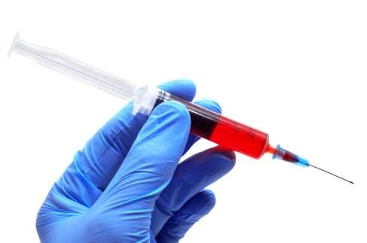
- If a diagnosis of PKU is confirmed, the child will need regular blood tests to measure levels of phenylalanine in their blood and assess how well they are responding to treatment.

Treatment
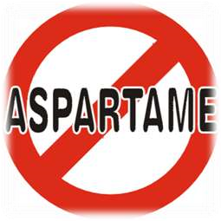

- Phenylketonuria (PKU) can be successfully treated with a low-protein diet and dietary supplements.
- The diet must be strictly followed.
- Those who continue the diet into adulthood have better physical and mental health.
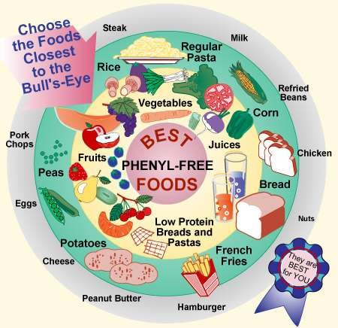

Prognosis

- The outcome is expected to be very good if the diet is closely followed, starting shortly after the child's birth.
- If treatment is delayed or the condition remains untreated, brain damage will occur.

- If proteins containing phenylalanine are not avoided, PKU can lead to intellectual disability by the end of the first year of life.


